A Progress Report

on

VEHICLE NUMBER PLATE RECOGNITION SYSTEM INN NON PARKING AND PARKING ZONES

carried out as part of the course: AI2270
Submitted by

YUVRAJ AND ANANYA

219310285 AND 219310261

IV-AIML

in partial fulfilment for the award of the degree

of

BACHELOR OF TECHNOLOGY

In

Computer Science and Engineering(AIML)



Department of Artificial Intelligence and Machine Learning
School of Computer Science & Engineering
Manipal University Jaipur,
March 2022

Acknowledgement

This project would not have completed without the help, support, comments, advice, cooperation and coordination of various people. However, it is impossible to thank everyone individually; I am hereby making a humble effort to thank some of them.

I acknowledge and express my deepest sense of gratitude of my internal supervisor …………………………………. for his/her constant support, guidance, and continuous engagement. I highly appreciate her/his technical comments, suggestions, and criticism during the progress of this project “VEHICLE NUMBER PLATE RECOGNITION SYSTEM INN NON PARKING AND PARKING ZONES”.

I owe my profound gratitude to Sandeep Chaurasia, Head, Department of CSE, for his valuable guidance and facilitating me during my work. I am also very grateful to all the faculty members and staff for their precious support and cooperation during the development of this project.

Finally, I extend my heartfelt appreciation to my classmates for their help and encouragement.

Registration No. 219310285 and 219310261
Students Name Yuvraj and Ananya


Department of Computer Science and Engineering
School of Computing & Information Technology

Date:5 April 2023

CERTIFICATE

This is to certify that the project entitled “VEHICLE NUMBER PLATE RECOGNITION SYSTEM INN NON PARKING AND PARKING ZONES" is a bonafide work carried out as Project Based Learning (Course Code: AI2270) in partial fulfillment for the award of the degree of Bachelor of Technology in CSE-AIML, under my guidance by Yuvraj and Ananya bearing registration number 219310285 and 219310261, during the academic semester VI of year 2022-23.

Place: Manipal University Jaipur, Jaipur

Name of the project guide: ________________________

Signature of the project guide: ______________________

PROJECT BASED LEARNING PROGRESS REPORT GUIDELINES

COMPONENTS OF APPLICATION BASED PROJECT REPORT

Contents
Page No.
Cover page

Certificate
Abstract

Table of Contents (with page nos)

- Introduction
  - Objective of the project
  - Brief description of the project
  - Technology used
    - H / W Requirement
    - Software Requirement
- Design Description
  - Flow Chart
  - Data Flow Diagrams(DFDs)
  - Entity Relatoinship Diagram(E-R Diagram)
- Project Description
  - Data Base
  - Table Description
  - File/Database Design
- Input/Output Form Design
- Future scope
- Conclusion

1.1 Objective
The purpose of this project is to detect parked vehicle which create traffic jams and conjuction in non parking areas using drones .The purpose of creating a system to automatically detect cars parked in a non-parking zone is to improve traffic safety and enforcement by identifying and penalizing illegal parking. The system could use a combination of technologies such as computer vision, machine learning, and image processing to analyze images or video footage captured by cameras placed in the area.
The system would identify the license plates of parked cars and compare them to a database of registered vehicles to determine whether they are authorized to park in the area. .This is till now done manually , where a police officer clicks photos of the vehicle number plate parked in the non parking zone and an E chalan is cut in the name of registered owner of the vehicle.By implementing an automated system, cities and towns can improve their parking enforcement efficiency, reduce the workload of parking enforcement officers, and ensure a more equitable distribution of parking spaces. Additionally, it can reduce congestion caused by illegal parking and promote a safer and more efficient flow of traffic.

1.2 Overall Description
The product perspective for creating a system to detect cars parked in a non-parking zone using drones involves integrating a variety of technologies and components to create a comprehensive solution that can identify and report illegally parked vehicles. The system would consist of several components, including:

Drones: The drones would be equipped with cameras capable of capturing high-resolution images and video footage of parked vehicles in non-parking zones.
Computer vision and machine learning algorithms: The system would use computer vision and machine learning algorithms to analyze the captured images and identify parked vehicles.

License plate recognition software: The system would use license plate recognition software to identify the license plates of parked vehicles and compare them against a database of registered vehicles.
Communication system: The system would include a communication system to send alerts to enforcement agencies and parking management authorities about illegally parked vehicles.
The system would be designed to integrate seamlessly with existing traffic management and parking enforcement systems, and comply with local regulations regarding drone operations and data storage.

1.3 Technology used

1.3.1 Hardware requirements
1 .Webcam or camera: A camera connected to a computer or embedded in a device such as a Raspberry Pi, used for capturing live video feed for processing.
2 . Drone (for potential future expansion): A drone equipped with a camera for aerial surveillance and capturing live video feed for processing.

1.3.2 Software requirements
- Python: A popular programming language used for developing the vehicle number plate recognition system.
- OpenCV (Open Source Computer Vision Library): An open-source computer vision library that provides various functions for image processing, object detection, and machine learning.
- Haar cascade classifiers: Pre-trained machine learning classifiers provided by OpenCV for object detection, including number plate detection.
- Image processing libraries: Other Python libraries such as NumPy, PIL (Python Imaging Library), and matplotlib for image processing, manipulation, and visualization.
- IDE (Integrated Development Environment): An IDE such as PyCharm, Jupyter Notebook, or Visual Studio Code for writing and debugging Python code.
- Operating system: The project may be developed on a Windows, macOS, or Linux operating system, depending on the preferences and requirements of the project team.

Design Description

2.1 Flow Chart
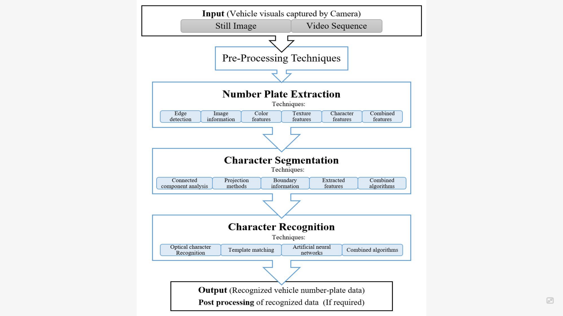

2.2 DFDs
Level 0 DFD:
| User Input |

| Image Input |

| Pre-processing | | (OpenCV Functions) |

| Plate Detection | | (OpenCV Functions) |

| Plate Recognition | | (Python Libraries) |

| License Plate Output|

| Database |

| Output Display |

Level 1 DFD (Plate Detection):
| Image Input |

| Image Pre-processing | | (OpenCV Functions) |

| Plate Localization | | (OpenCV Functions) |

| Plate Segmentation | | (OpenCV Functions) |

| Plate Candidate List |

| Plate Recognition | | (Python Libraries) |

| License Plate Output |

| Plate Detection Output|

2.3 ER diagram
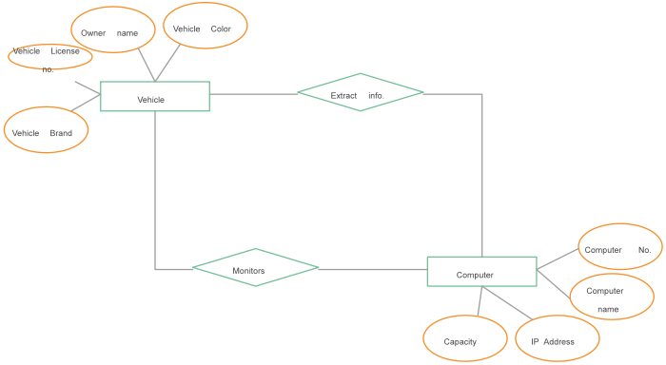

3.Input Output form design
Input:
Live video feed from a webcam or camera for initial detection
Potential future input from a drone for aerial surveillance and video feed

Output:
Detected vehicle number plate(s) with corresponding timestamp
Processed and analyzed data of the recognized number plates
Potential alerts or notifications for unauthorized or suspicious vehicles
Logging or storing of the recognized number plates for future reference

Form Design:
The form may have a clean and user-friendly interface with a video feed display from the webcam or drone.
The form include buttons or controls for starting and stopping the detection process, adjusting settings, and displaying results.
The form display the recognized number plates in a clear and organized manner, along with relevant information such as the timestamp and location.
The form provide options for exporting or saving the recognized number plates and data for further analysis or reporting.
The form also include a logging or tracking feature to record the recognized number plates for future reference or analysis.
Functionality:
The form may use OpenCV and Python for real-time video processing, object detection, and number plate recognition.
The form incorporate image processing techniques using OpenCV for preprocessing and enhancing the input video feed for better detection accuracy.
The form implement Haar cascade classifiers provided by OpenCV or other custom-trained classifiers for detecting the number plates in the video feed.
The form use algorithms or techniques for extracting and recognizing the characters from the detected number plates.
The form generate alerts or notifications for unauthorized or suspicious vehicles based on predefined rules or criteria.
The form may log or store the recognized number plates and corresponding data for future reference or analysis.

4.Scope in future
The product scope for creating a system to detect cars parked in a non-parking zone using drones would involve developing and implementing a technology solution that can:
Identify non-parking zones: The system should be able to identify non-parking zones, such as restricted areas, no-parking areas, and loading zones.

Deploy drones: The system would involve the deployment of drones equipped with cameras to capture images and video footage of parked vehicles.

License plate recognition: The system would use computer vision and machine learning algorithms to recognize license plates and identify parked vehicles.

Alert authorities: The system should be able to alert the relevant authorities or enforcement agencies in real-time about any illegally parked vehicles.

Data storage: The system should store the captured images and data in a secure, centralized database for future reference and analysis.

Analyze and generate reports: The system should be able to analyze the data collected and generate reports for enforcement agencies and local authorities.

Integrate with existing systems: The system should integrate with existing traffic management and parking enforcement systems.

Comply with regulations: The system should comply with local laws and regulations regarding privacy, data storage, and drone operations.
Overall, the product scope would involve developing a comprehensive technology solution that leverages drones to detect illegally parked vehicles in non-parking zones and provide real-time alerts to enforcement agencies.

5.Conclusion
In conclusion, vehicle number plate recognition technology is a promising solution for improving the management and enforcement of non-parking and parking zones. Through the use of cameras and advanced algorithms, this technology has the potential to greatly enhance the efficiency and effectiveness of traffic enforcement, reduce traffic congestion, and improve overall road safety.
The findings of this project report highlight the numerous benefits of implementing vehicle number plate recognition in non-parking and parking zones, including increased accuracy in identifying violators, reduced manual labor and human error, and enhanced data collection and analysis capabilities. Additionally, the use of this technology can also contribute to revenue generation through fines and penalties, which can be used to further improve traffic management infrastructure and systems.
With careful planning and implementation, vehicle number plate recognition technology has the potential to revolutionize traffic management and make our roads safer and more efficient for everyone.

